Painting with Light Session - Monday October 23rd at 8.00pm
Meeting Point: Adlington Road Car Park, Bollington. Post Code SK10 5JT
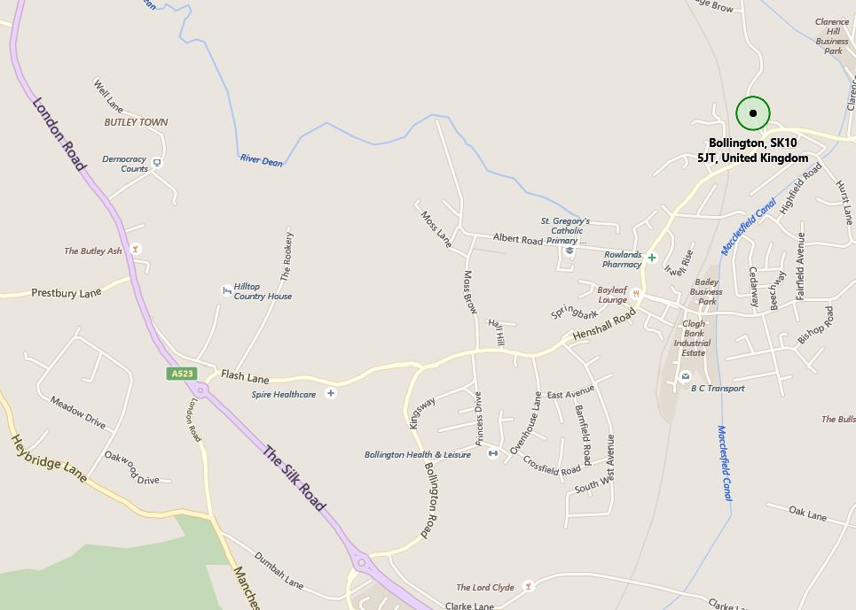

Equipment Required :
Essential:
- DSLR, or camera with manual settings that include “Bulb”
- Lens with a focal length ~24mm to 60mm
- Sturdy tripod that is not affected by wind
- Digital watch or timer (or remote that has a timer)
- Penlight or small flashlight to be able to check camera settings
- Powerful flashlight like a Maglite for light painting.
- Light sources with different coloured lights (or filters) e.g. LED light or red light
- A speedlight or portable flash unit which can also be used for light painting
Preferable:
- At least one extra battery for your camera
- Lens hood or shade for your lens
- Rain covers for your camera bag and camera
- Warm weather gear and footwear
- Electric cable release or remote trigger with a locking mechanism or timer
Camera Settings

- File format – shoot RAW whenever possible lighting at night can be odd colors
- White balance – generally choose “incandescent” or “tungsten” White Balance Preset when doing light painting because it will balance correctly for flashlight.
- Focus – your camera has a hard time focusing at night and will “hunt” unless you find focus and lock it for all your exposures. If your camera has back button focus capabilities I’d suggest using that, if not you can focus and then turn it to manual focus so it doesn’t attempt to refocus when you hit the shutter release. You can try to focus using manual but keep in mind if your camera can’t see in the dark, neither can you! So to achieve focus use your flashlight, and if you have a friend along, get them to light up the part of the object you want to focus on. Then either use your auto focus and lock it, or manually focus and then don’t touch it!
- Manual mode or BULB – for exposure set it to manual. That way the camera is not trying to guess the correct exposure. We’ll be setting it and leaving it for the most part – just like our focus. For exposures longer than 30 seconds (30″ on your camera) you’ll need to find and use your BULB setting. On many cameras it is right after 30 seconds on the shutter speed scale, one some there’s a B option on your mode dial on top of your camera.
- ISO – for this purpose and most of the times you are on a tripod it is always best to choose the lowest ISO possible to minimize the noise. Ideally 100-200 ISO
- Aperture – start around f/5.6 – depending on your scene, then adjust from there if you want more or less depth of field. Keep in mind the smaller aperture you use, each stop you close down doubles the amount of time you need to be painting and exposing. So a 60 second exposure at f/5.6 becomes an 8 minute exposure at f/16!
- Shutter speed – start around 30 seconds and increase as necessary
Painting with Light
- To keep yourself invisible, always make sure the flashlight is aimed at the subject, and that you do not light up yourself, dark clothing helps too. Also keep moving during the whole exposure. Don’t stand in one place for more than a couple seconds or you will show up as a ghost in that spot.
- Aim the flashlight at an angle back towards the camera,
- Keep the light moving the whole time so as not to create any harsh lines or bright spots. Make outlines of the shape of the subject or parts of it.
- For a more defined and abstract look to your light painting you must come in a REALLY close to the subject! By that I mean about 1-2 feet away from the subject. YES you are going to get right into the scene. But if you keep moving, and keep your light moving you will not show up in the photo. Also make sure your flashlight beam is focused to a small area – a Maglites will focus down to a small spot.
- For a broader more even light keep the flashlight beam wide and stand back from the subject a bit (4-8 feet) and light it from the side to create a nice cross light and texture on the subject.
- Try using a combination of the illumination and light streak techniques in one photo.
- Use coloured bulbs and filters to give your light a different glow, perhaps changing colours for different parts of the scene.

Ideas for painting with light
Single group activity
1) Ignited wire wool spinning demonstration
2) LED display

In groups of 3-4
1) Member(s) use the light sticks provided to be creative
2) Member(s) use the sparklers provided to be creative
3) Person paints their name with a flashlight (white or coloured light)
4) Person paints the outline of their body (white or coloured light)
5) Person moves around and fires their flashgun onto their body (or face)
6) Person(s) move about in a random fashion with different coloured lights
7) Persons(s) stand stationary and rotates different coloured lights

Terry Heathcote
Mobile: 07551326152

